Just look into previous learning things.

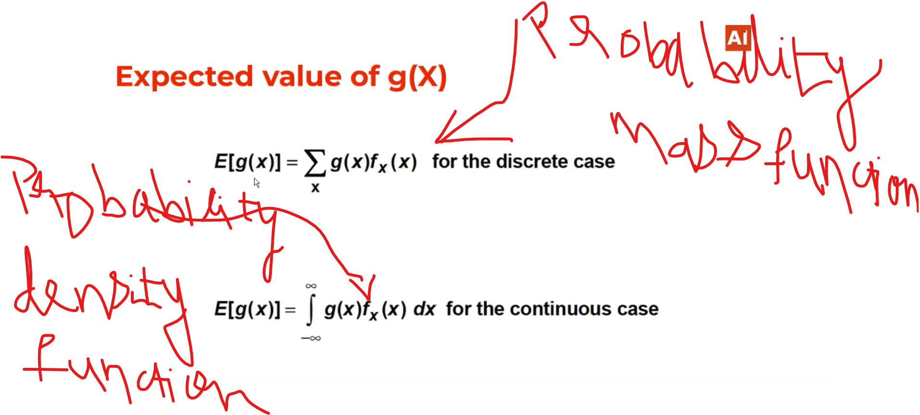

Variance: Measure of Spread

Consider a random variable and there is a function probability distribution function associated with it. Variance of that Random variable tells you what the measure of the spread of the distribution around the mean is of the random variable

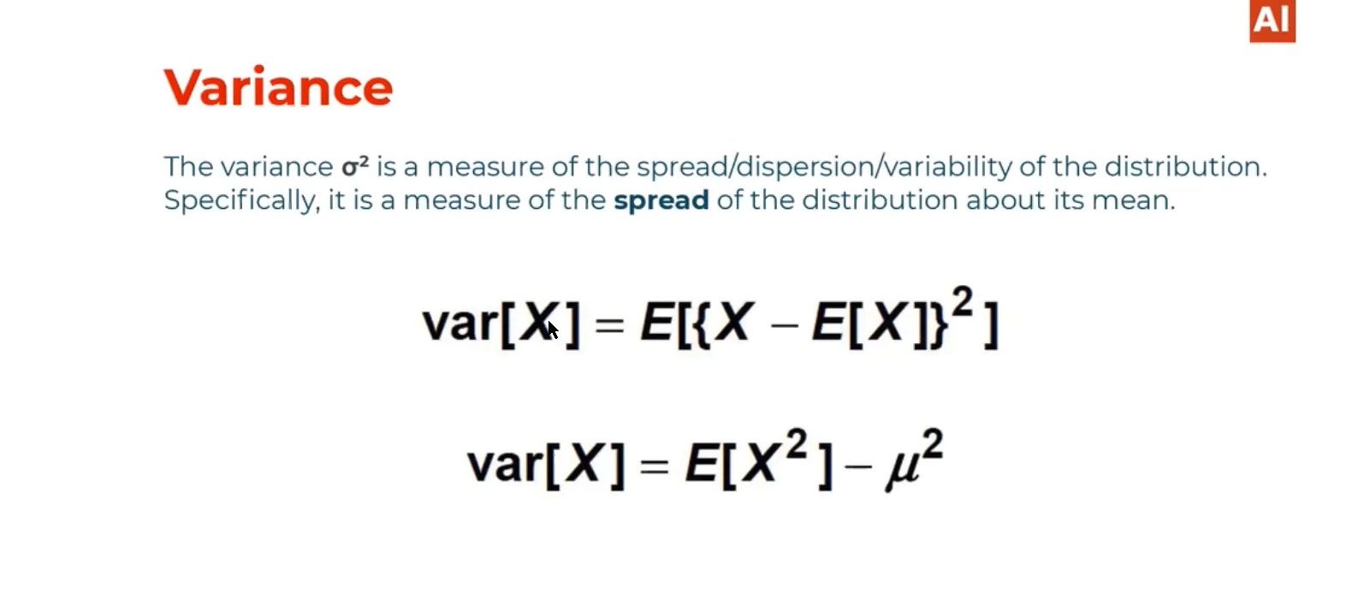

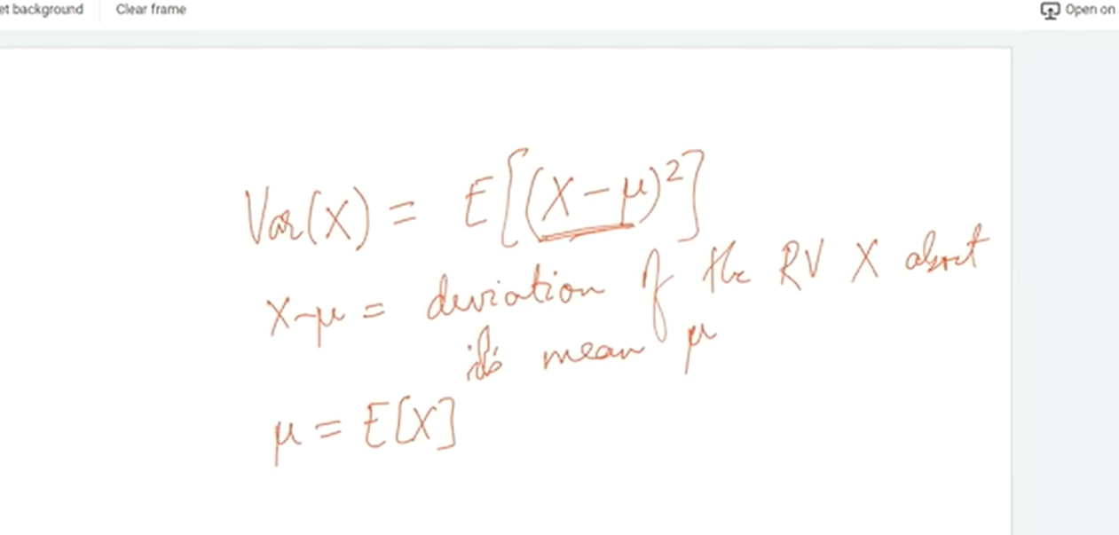

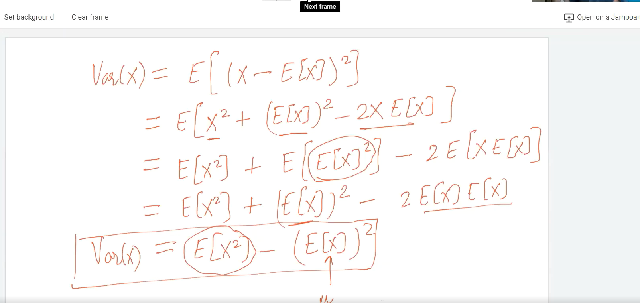

# Expectation when a dice rolled(Discrete Random variable):

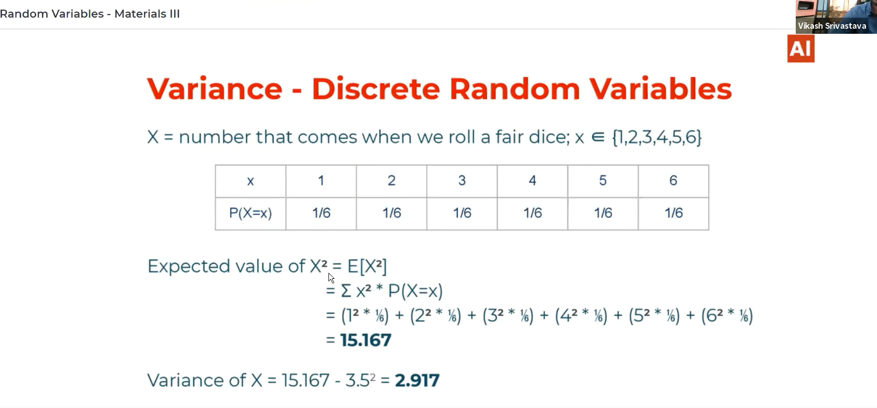

# Expectation and variance for a continuous random variable:

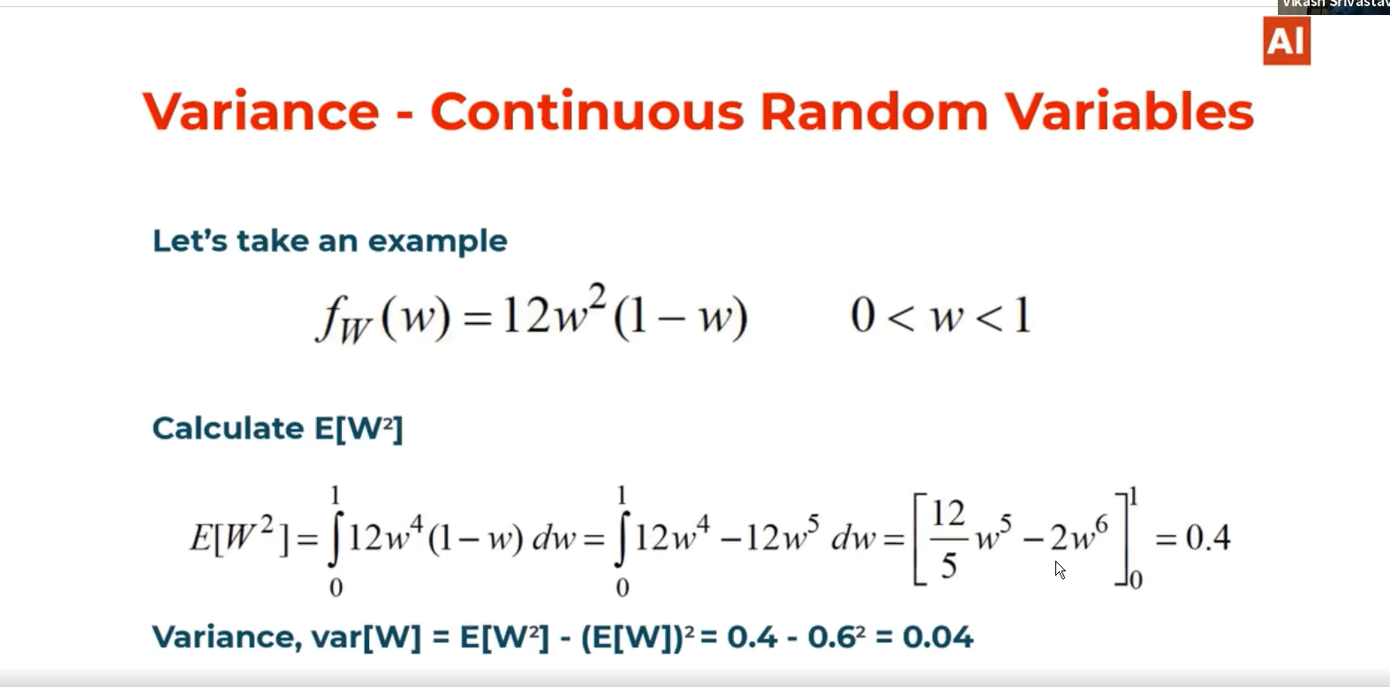

# Mean and Variance of Linear combinations:

A and B are scalers.

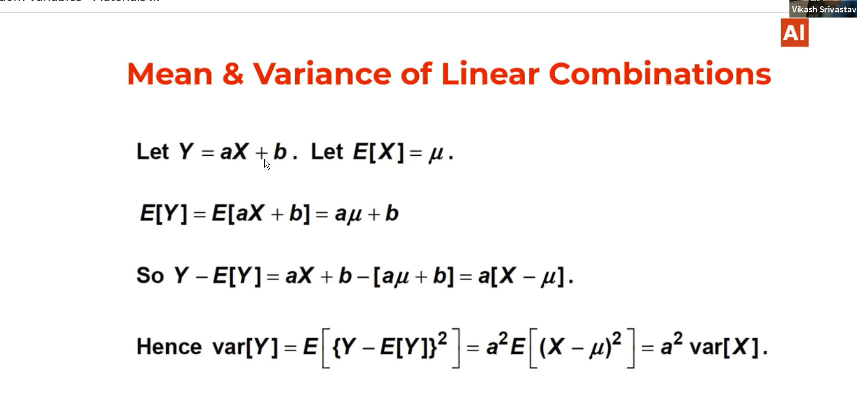

# Discrete Random Variables:

We can associate PDF to a random variable. Probability distributions of discrete random variables or discrete probability distributions which can be used to model some natural processes. But in reality when the processes becomes more complex there ML takes place. To model natural processes we use Probability distributions. There are many distributions are there,

# Uniform Distribution:

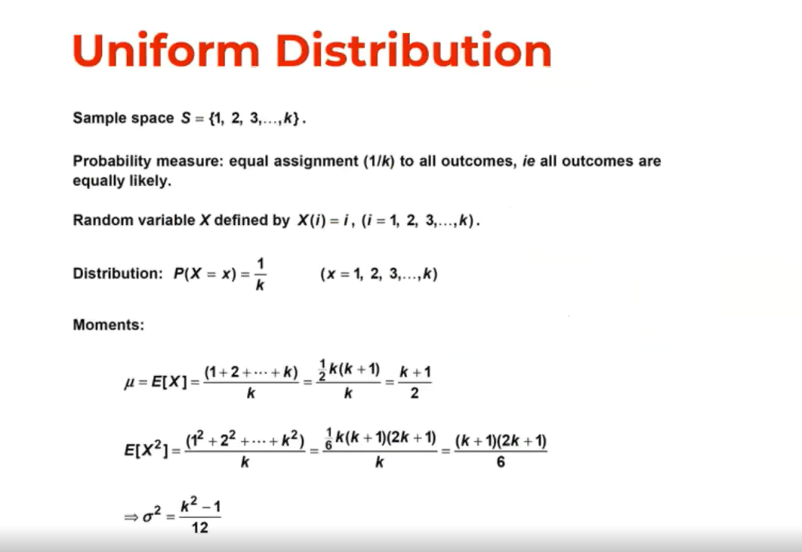

# Expectation of uniform distribution: (Meu)

Here we calculate Mean and variance because based upon these parameters the shape of the distribution varies.

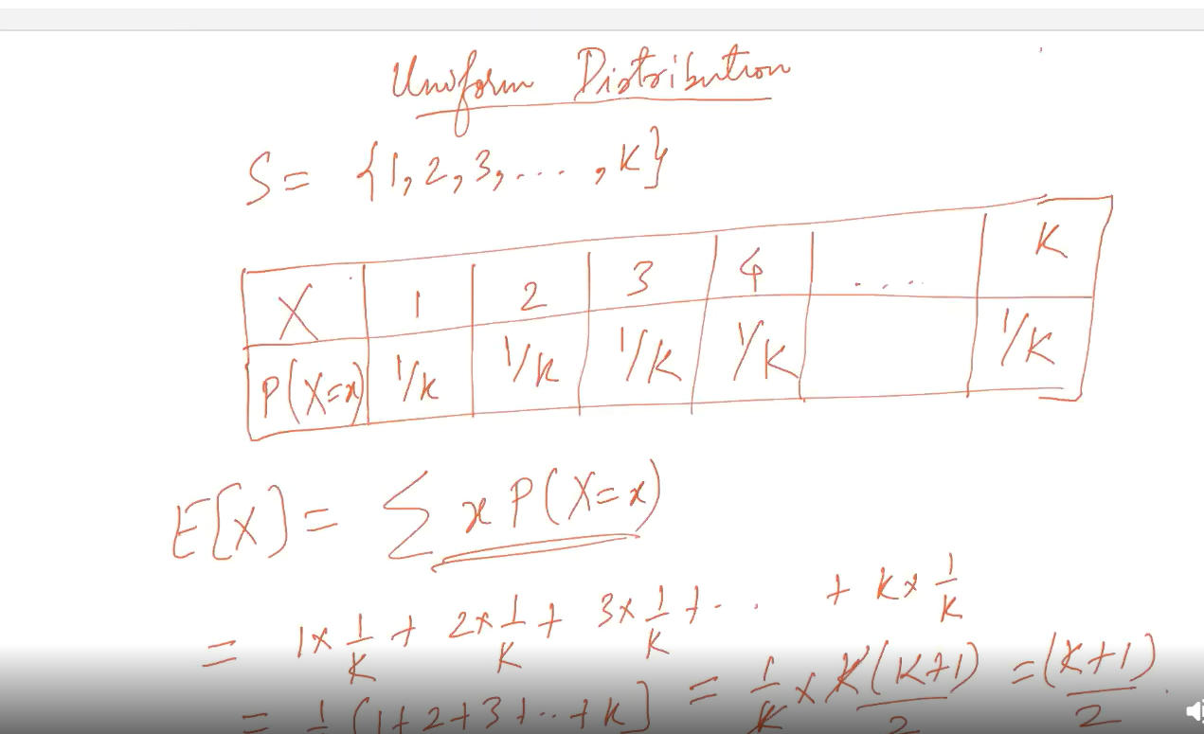

# Variance of X:(Sigma)

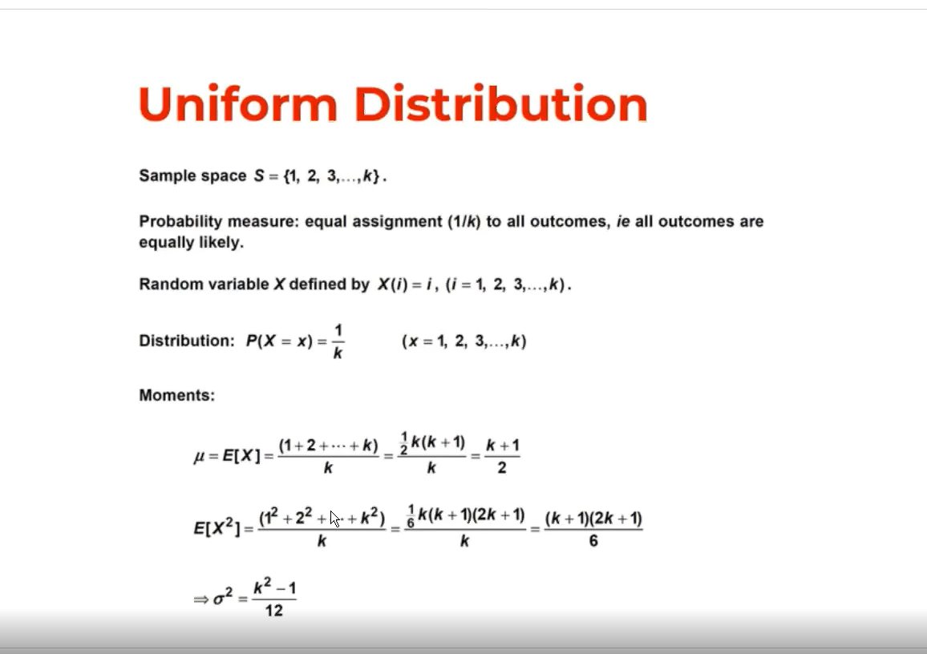

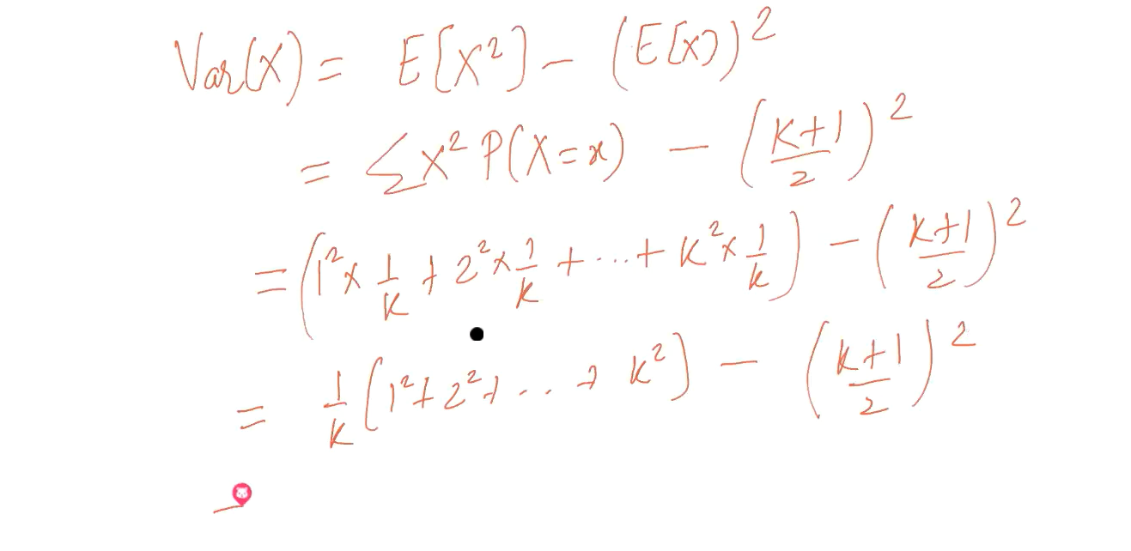

# Bernoulli Distribution:

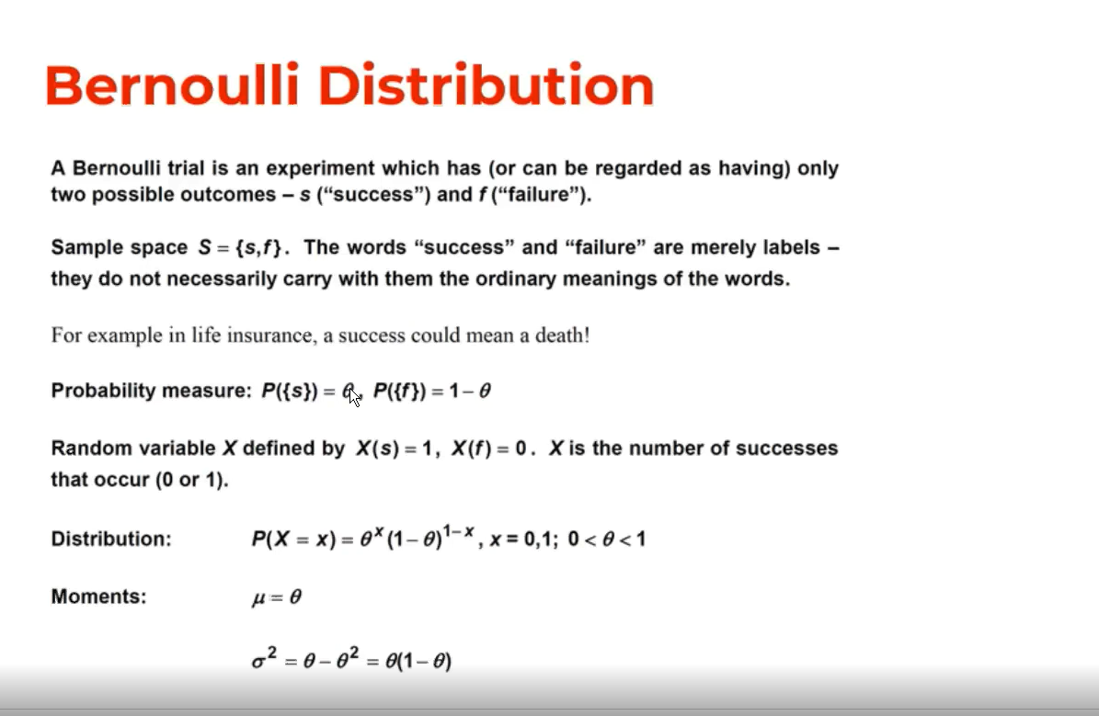

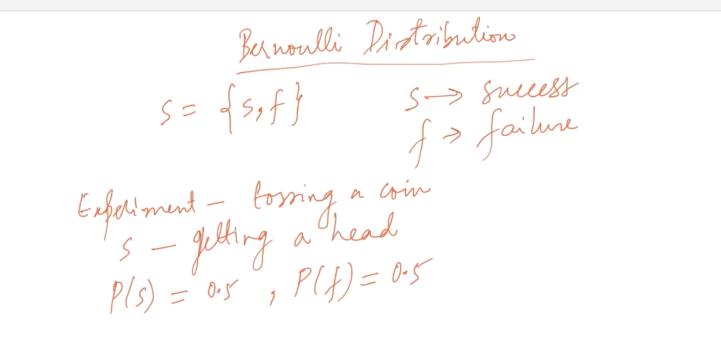

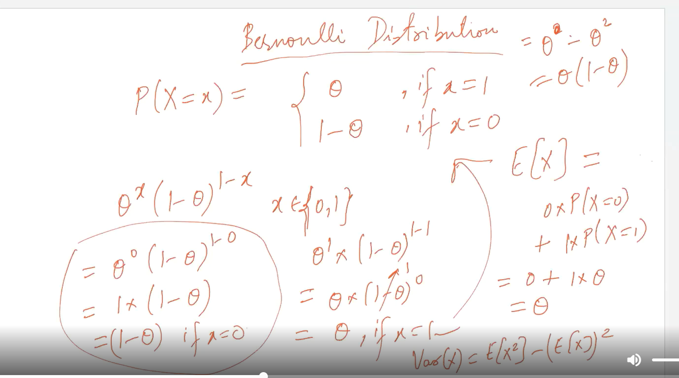

# Moment of generation:

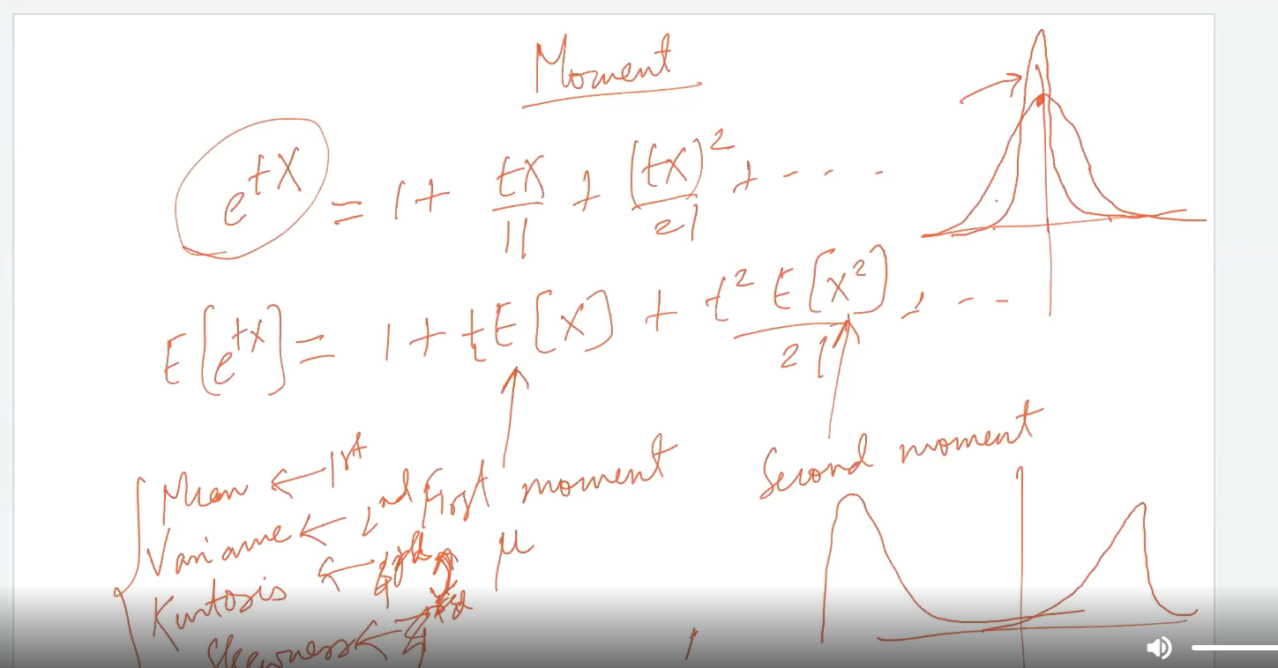

# Bernoulli distribution on tossing a coin:

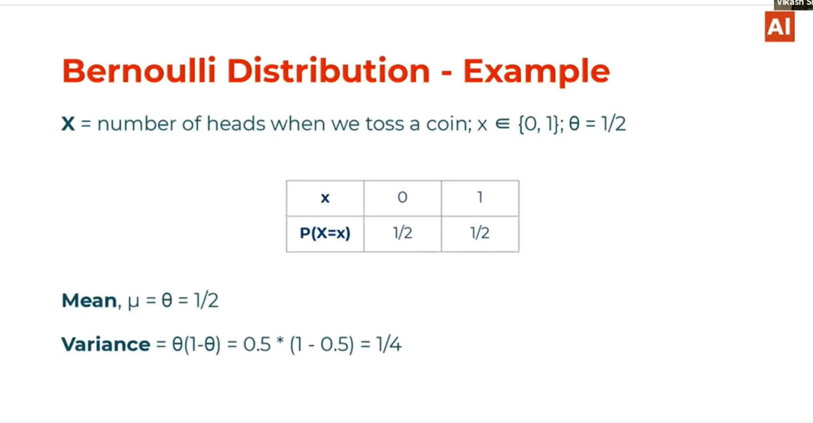

# Bernoulli trails:

Here picking one ACE card among 52 cards is considered as P(Success)🡪 1/13 but after that picking one more ACE in the same deck P(Success)🡪 3/51. Its not considered as Bernoulli’s distribution because the second trial got effected by the first trial. There fore picking ACE in a deck of 52 cards is not example of Bernoulli trial because next trial is dependent on first trial. It is a special case of a Binomial distribution where the no. of trials are 1.

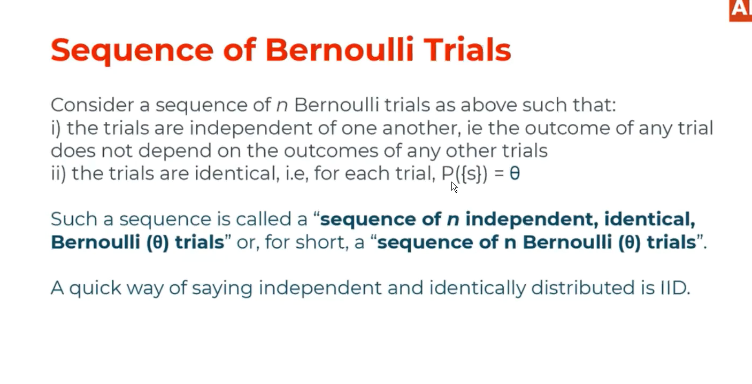

# Binomial distribution:

The number of trials X Bernoulli distribution

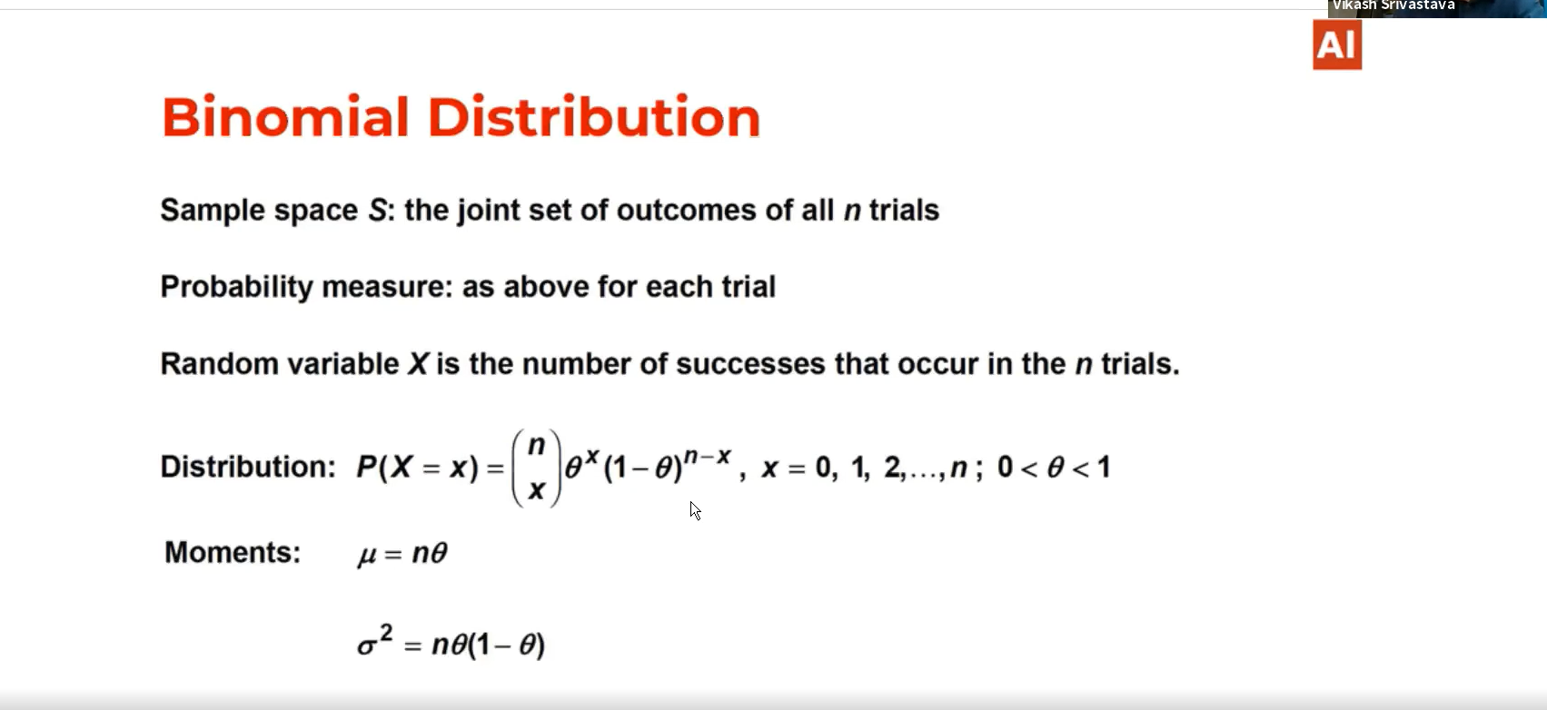

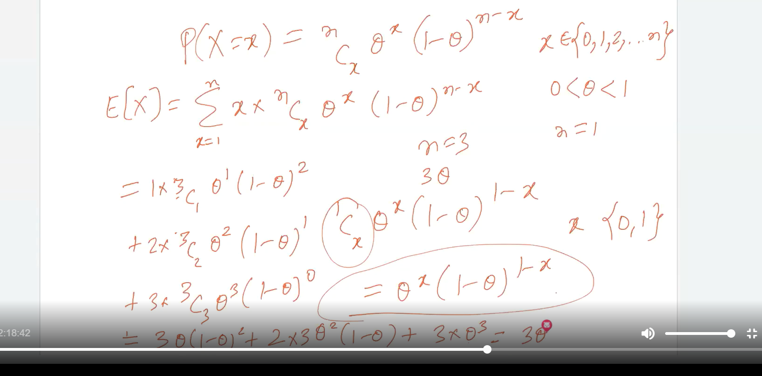

# Geometric Distributions:

This used when we want to calculate the number of trials need to perform inorder to get first success.

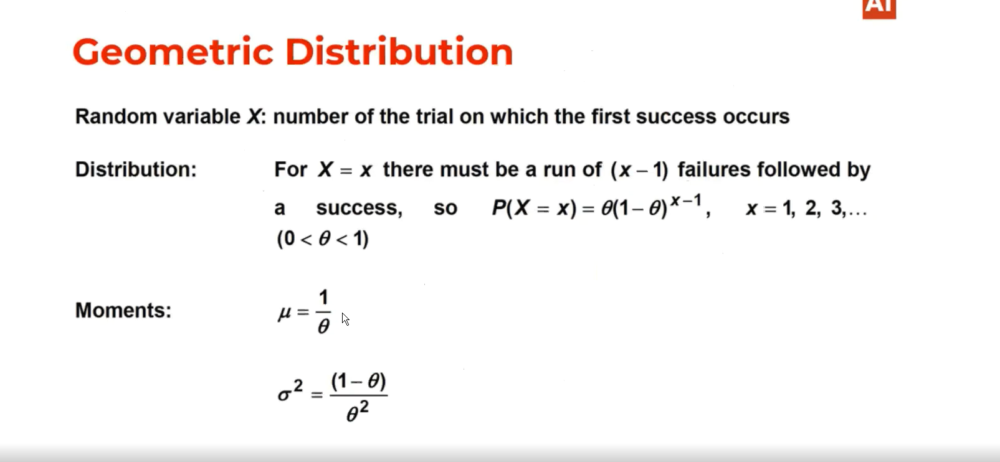

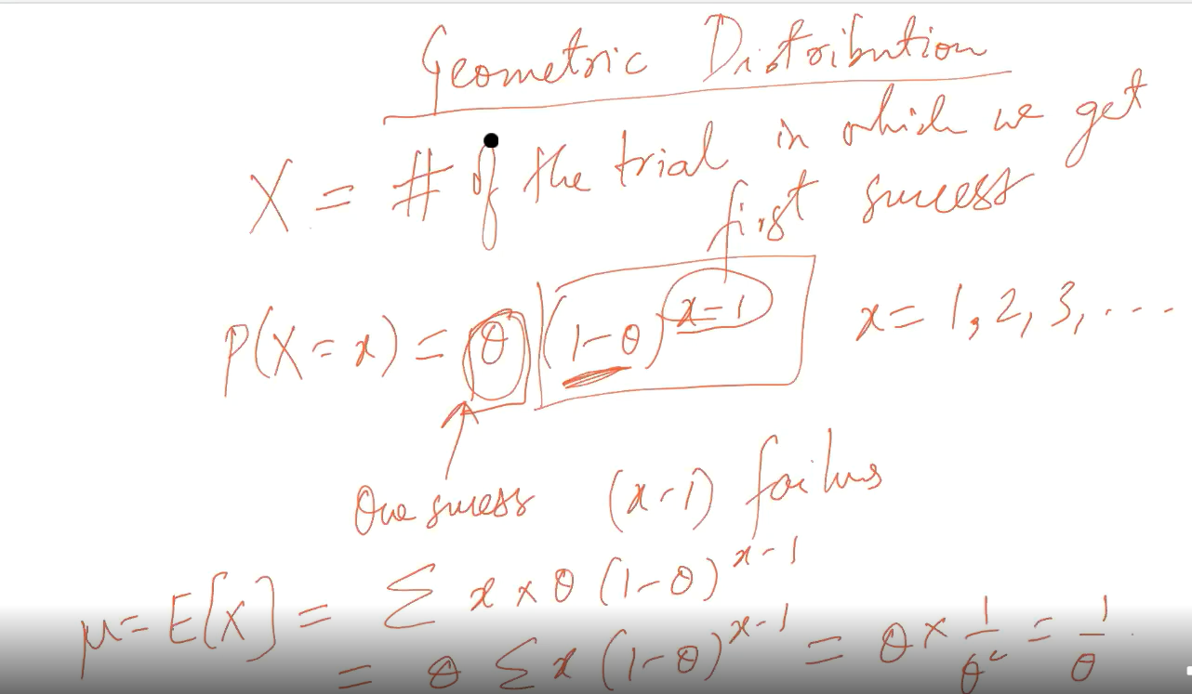

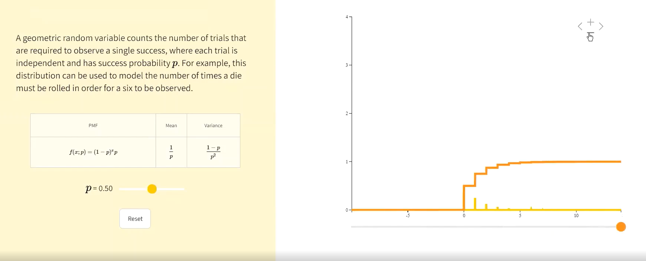

# Poisson Distribution:

Consider on and average in match 3 Goals can be done. I that case Lambda=3 and if we want to calculate the probability of doing 5 goals in that case Poisson distribution is used.

